To do list for Nature Submission
Links:
- Formatting guidelines
- Initial submission guidelines

THINGS ISHANA HAS MISSED OR DOES NOT FULLY UNDERSTAND
- Table formatting: Do they need their own page? Is in text OK?
- Does the 3,000 word methods section need to be submitted with the main text

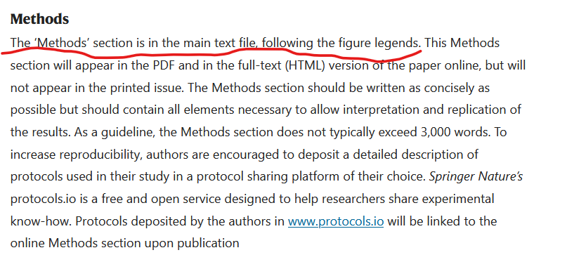https://www.nature.com/nature/for-authors/initial-submission

  - Does it count towards the overall work count? (See linked guidelines)
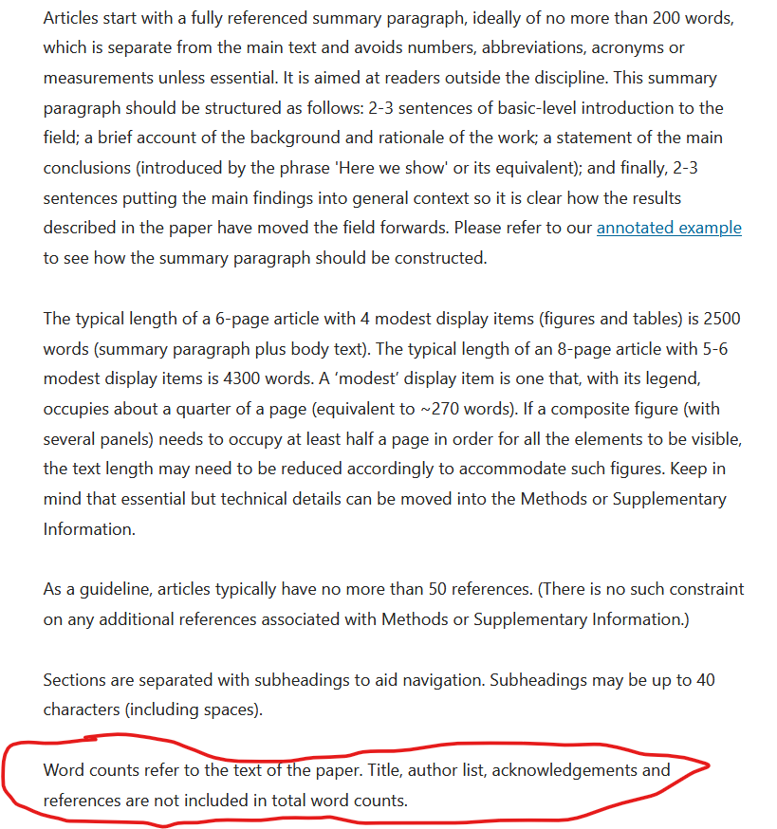
https://www.nature.com/nature/for-authors/formatting-guide
My read is that the methods section, should be included on the main document submissions, but doesn’t count towards page length
- Please double check requirements for footnotes. Ishana is bad at them.
- Need to customize an endnotes section that starts with “endnotes”
  - Where do the endnote markers go? They’re not endnotes in final articles (e.g. https://www.nature.com/articles/s41586-025-09819-w) so I’ve done my best but please take a look
There are no endnotes in the final submissions, you are correct, I would just have them as a section at the end, as they are presented in published nature articles, but up to you. I’m sure its also fine if you submit them as endnotes.
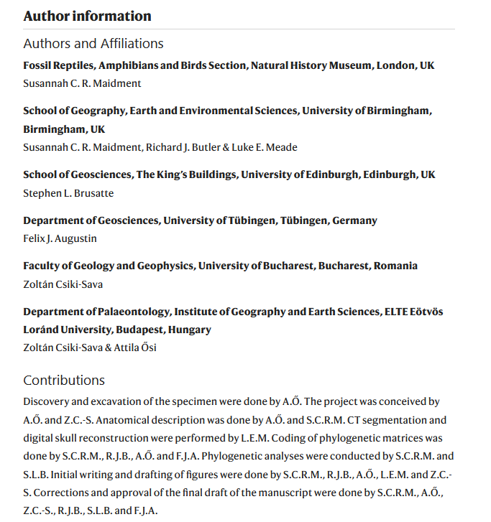
  - Where does the author's contribution endnote marker go? (See list item 6 for details)
    - At the end of the author list on the main page? Or does each author get one?
    - List item number 5 details how to write author contributions
Again I would just circumvent this whole thing and just add an author information section and contributions section at the end of the manuscript like in published nature papers
- PLEASE DOUBLE CHECK SI NUMBERING. Ishana has done this. But Ishana makes mistakes. (does the SI number in the paper reference the correct table)

- Final data double check
- Table 1
- Figure 1 (figure quality)
- Figure 2 (color + figure quality)
- Figure 3 (color + figure quality)
- Figure 4 (color + figure quality)
- Table A.1
- Model Performance in-text
- Table A.2
- Supplementary Information Double Check (and cry)
  - SHAP tables
  - Cross Validation figures (color + figure quality)
  - Predicted competition figures (Figure quality)
  - Ranking consistency (Figure quality)

- Summary Paragraph
Countries are increasingly leveraging green industrial policies to both pursue decarbonization and improve the position of domestic industry in global value chains. Yet there is deep uncertainty about which technologies make for good investments, and poorly targeted strategies risk costly investment in crowded sectors. Here we predict country competitiveness across ten clean energy technologies using a machine-learning model built on granular measures of industrial capabilities. The results reveal that competitiveness depends upon a core set of industrial capabilities: electronics, machinery, mining and metals, industrial materials, and chemicals. Moreover, each technology has a unique profile of capabilities that predict competitiveness. This work advances the study of green industrial policy by providing a clear profile of capabilities necessary for competition in key green technologies, and a strategy for countries to identify their strengths and weaknesses across the supply chain. As countries implement green industrial policies, it will be critical that states avoid over-investments in sectors where they lack capabilities and play to their strengths in green value chains.

- OPTIONAL Cover letter *not seen by reviewers
- Disclose details of any related manuscripts that all authors have under consideration or in press elsewhere.
- Let us know whether you have had any prior discussions with a Nature Climate Change editor about the work described in the manuscript.
- If choosing double-blind peer review, include the affiliation and contact information for all authors (instead of putting it in the manuscript file).
- OPTIONAL. Provide the name and institution of reviewers you would like to recommend and/or people you would like to be excluded from peer review

- Formatting requirements
- Double spaced
- Main text of 2,500 words (we are at 2,600)
- 200 word abstract (we are at ~150)
- Figure formatting:
  - Provide images in RGB color and at 300 dpi or higher resolution.
  - Use the same typeface (Arial or Helvetica) for all figures. Use symbol font for Greek letters.
  - Use distinct colors with comparable visibility and avoid the use of red and green for contrast. Recoloring primary data, such as fluorescence images, to color-safe combinations such as green and magenta or other accessible color palettes is strongly encouraged. Use of the rainbow color scale should be avoided.
  - Figures are best prepared at a width of 90 mm (single column) and 180 mm (double column) with a maximum height of 170mm.. At this size, the font size should be 5-7pt.
  - We require vector files with editable layers. Acceptable formats are: .ai, .eps, .pdf, .ps, .svg for fully editable vector-based art; layered .psd or .tif for editable layered art; .psd, .tif, .png or .jpg for bitmap images; .ppt if fully editable and without styling effects; ChemDraw (.cdx) for chemical structures. A guide to preparing final figures is available here: Figure style guide.
  - Please refer to the Nature Research chemical structures style guide for formatting of chemical structures.

- Author contributions
- http://www.nature.com/authors/policies/authorship.html
- Informed summaries of author contributions (Jonas)
^use really specific words
- Perhaps words are located here: https://www.nature.com/articles/4581078a
- Include in endnotes of paper

- Endnotes
- Reference numbers are superscript
- Submission of a competing interests statement is required for all content of the journal.
- Papers containing Supplementary Information contain the statement: “Supplementary Information is available for this paper.”
- A sentence reading "Correspondence and requests for materials should be addressed to XX.”
- A sentence reading “Reprints and permissions information is available at www.nature.com/reprints.”

